

**ChipletRing APP SDK manual**

|  |  |  |  |
| --- | --- | --- | --- |
| Document Version number: | 1.1.2 | Document No. : |  |
| Document secret level: |  | Department: | Chiplet Research and Development Department |
| Product Name: | BCL_603M | Attribution Items: |  |
| Writer: | Zheng Yuhu | Date written: | 2023.10.19 |

**Copyright Wuxi Yongxin Technology Co., LTD. All rights reserved**

**nullRevision Record:**

|  |  |  |  |
| --- | --- | --- | --- |
| **Version Number** | **Revision person** | **Date of revision** | **Revised Description** |
| 1.0.0 | Zheng Yuhu | 2023.10.19 | Modifying Navigation Directory |
| 1.0.1 | Zheng Yuhu | 2023.10.26 | Modify the description of integration and initialization SDK, modify part of the demo code |
| 1.0.2 | Zheng Yuhu | 2023.10.31 | Complete code, add FAQ |
| 1.0.3 | Zheng Yuhu | 2023.11.23 | Updated the Q&A, modified the parameter description for reading data |
| 1.0.4 | Zheng Yuhu | 2023.11.29 | Added Q&A as a summary for follow-up simple questions |
| 1.1.1 | Zheng Yuhu | 2023.12.26 | 1. Added screening method for Bluetooth scanning  2. Measure heart rate, measure blood oxygen increase upload data |
| 1.1.2 | Zheng Yuhu | 2024.01.02 | Added waveform graph data analysis |
| 1.1.3 | Zheng Yuhu | 2024.04.19 | Increase heart rate, blood oxygen, PPG raw data analysis |

**nullCatalog**

1. Introduction to the document null5

1. Document purpose null5

2. Scope of application null5

3. Function introduction null5

2. Quick Start Overview null6

1. Preconditions null6

2 Use the process null6

3. Flow Chart null7

Integrate ChipletRing APP SDK null8

1. Integrate the ChipletRing APP SDK null8

1.1 Integration Methods null8

1.1.1 Get the jar package file of the ChipletRing APP SDK null8

1.1.2 Place the jar package in the libs directory null8

1.1.3 Right-click to Add as Library(Add as Class Library) null8

1.1.4 Configure the required permissions. If storage and other permissions are required, they can be configured by themselves. If dynamic permissions are involved, relevant processing needs to be done null8

2 Initialize the ChipletRing APP SDK null9

2.1.1 Initialize in the onCreate method of Application null9

2.1.2 In the BaseActivity class, enable the listener, which is used to listen for the Bluetooth connection status and the data fed back by the ring basic command null9

3 Use the ChipletRing APP SDK null10

3.1 Bluetooth Operation (BLEUtils) null10

3.1.1 Search for devices null10

3.1.2 Stop the search null11

3.1.3 Connecting devices null11

3.1.4 Disconnect Bluetooth null12

3.2 Instruction Functions (LmAPI) null12

3.2.1 Sync Time null12

3.2.2 Read time null12

3.2.3 Version information null13

3.2.4 Battery level null13

3.2.5 Reading steps null14

3.2.6 Clear steps null14

3.2.7 Restore factory Settings null15

3.2.8 Collection period Settings null15

3.2.9 Acquisition cycle read null15

3.2.10 Measure your heart rate null16

3.2.11 Measure blood oxygen null17

3.2.12 Measure the temperature null18

3.2.13 History Management null19

3.2.14 Clear historical data null20

3.3 Firmware Upgrade (OTA) null21

3.3.1 Check the version null21

3.3.2 Start the upgrade null22

3.4 Database Correlation (DataApi) null23

3.4.1 Query history null23

3.4.2 Clearing historical data null24

3.5 Logical Algorithm Correlation (LogicalApi) null25

3.5.1 Calculate distance, calories null25

3.5.2 Calculating sleep data null25

Iv. Others null27

1. Filter relevant null27

1.1 Broadcast data unit null28

1.1.1 Raw data: null28

1.1.2 Details: null29

1.2 Application null29

2. Possible problems null29

2.1 version Related null30

2.2 Gradle 4.0 or above causes Xpopup to be unusable null30

2.3 No interface required null30

2.4 OTA Class Reference not found null30

3, hardware algorithm logic or firmware related null31

3.1 Ring Related null31

3.2 Algorithm Correlation null31

4, Q&A null31

null

# Document Brief

## Document purpose

In order to facilitate the secondary development of the communication between the Android APP and the ring, the communication protocol is specially encapsulated to achieve simplicity and clarity, so that developers do not need to pay attention to the communication layer with the ring, and focus on the development of business logic interaction level.

## Scope of application

This SDK is based on Android native development, and is ultimately provided as a jar package library.It can be used in the Android environment.

## Function Description

|  |  |  |
| --- | --- | --- |
| Function module | Instructions | Relevant documentation |
| Bluetooth basic module | * Switch operation of Bluetooth * Bluetooth search link operation * Bluetooth data write listening operation |  |
| Communication protocol module | * Time management * Version number management * Battery Management * Heart rate measurement * Blood oxygen measurement * Temperature measurement * Step management * History management * System Settings * Log management |  |

null

# Quick Start Overview

## Preconditions

* The operating system is Android and the operating system version is >=5.0
* Must support Bluetooth 5.0
* The jar package can be invoked using the language

## Use process

Follow the following process to use the SDK:

Step 1: Integrate the SDK

Step 2: Initialize the SDK

Step 3: Use the SDK

## Flowchart

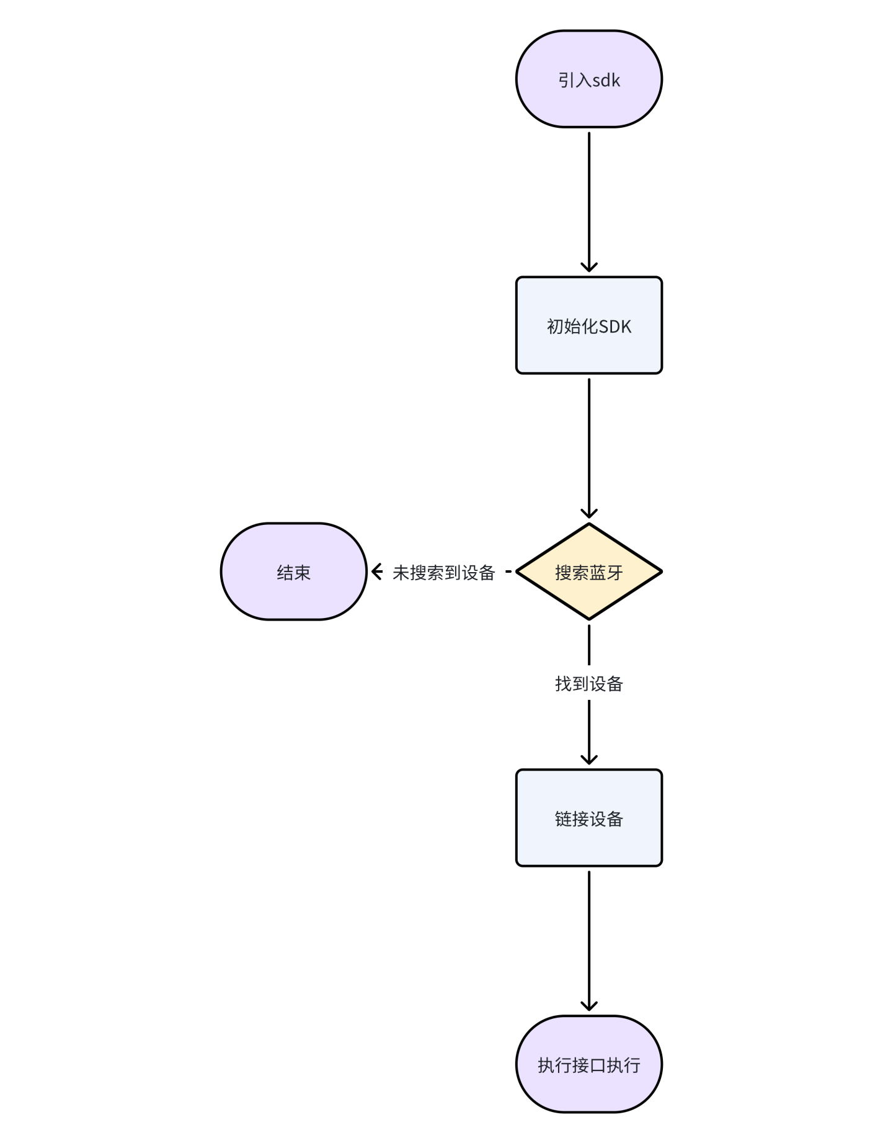

# Integration with the ChipletRing APP SDK

## Integrate the ChipletRing APP SDK

### Integration method

#### Get the jar package file of ChipletRing APP SDK

#### Place the jar package in the libs directory

#### Right click and set to Add as Library(add as class library)

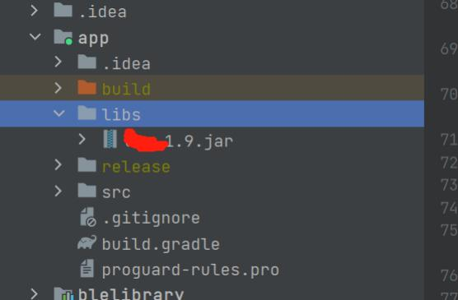

#### **Configure the required permissions, such as storage and other permissions can be configured by yourself, involving dynamic permissions, need to do related processing**

Add the following code to the Manifest.xml

|  |
| --- |
| 1. <uses-permission android:name="android.permission.BLUETOOTH_ADVERTISE" /> 2. <uses-permission android:name="android.permission.BLUETOOTH_CONNECT" /> 3. <uses-permission android:name="android.permission.BLUETOOTH_SCAN" /> 4. <uses-permission android:name="android.permission.ACCESS_COARSE_LOCATION" /> 5. <uses-permission android:name="android.permission.ACCESS_FINE_LOCATION" /> |

## Initialize the ChipletRing APP SDK

#### Initialize in the onCreate method of the Application

|  |
| --- |
| 1. LmAPI.init(this); 2. LmAPI.setDebug(true); |

#### In the BaseActivity class, enable listening, which is used to listen for the Bluetooth connection status and the data fed back by the ring's basic instructions

|  |
| --- |
| 1. LmAPI.addWLSCmdListener(this, this); 2. *// Monitor the status of the connection between the Bluetooth device and the APP* 3. IntentFilter intentFilter = new IntentFilter(); 4. intentFilter.addAction(BluetoothAdapter.ACTION_STATE_CHANGED); 5. intentFilter.addAction(BluetoothDevice.ACTION_ACL_DISCONNECTED); 6. intentFilter.addAction(BluetoothDevice.ACTION_ACL_CONNECTED); 7. registerReceiver(broadcastReceiver,intentFilter); 8. *// Ask for permission to disable Bluetooth before using it* 9. if (Build.VERSION.SDK_INT >= Build.VERSION_CODES.S) { 10. if (!checkPermissions(new String[]{Manifest.permission.ACCESS_COARSE_LOCATION, Manifest.permission.ACCESS_FINE_LOCATION, Mani fest.permission.BLUETOOTH_SCAN, Manifest.permission.BLUETOOTH_CONNECT, Manifest.permission.BLUETOOTH_ADVERTISE})) { 11. new XPopup.Builder(this).asConfirm(getRsString(R.string.hint), getString(R.string.localtion_auth), 12. new OnConfirmListener() { 13. @Override 14. public void onConfirm() { 15. requestPermission(new String[]{Manifest.permission.ACCESS_COARSE_LOCATION, Manifest.permission.A CCESS_FINE_LOCATION, Manifest.permission.BLUETOOTH_SCAN, Manifest.permission.BLUETOOTH_CONNECT, Manifest.permission.BLUE TOOTH_ADVERTISE}, 100); 16. } 17. }).show(); 18. return; 19. } 20. } else { 21. if (!checkPermissions(new String[]{Manifest.permission.ACCESS_COARSE_LOCATION, Manifest.permission.ACCESS_FINE_LOCATION})) { 22. new XPopup.Builder(this).asConfirm(getRsString(R.string.hint), getString(R.string.localtion_auth), 23. new OnConfirmListener() { 24. @Override 25. public void onConfirm() { 26. requestPermission(new String[]{Manifest.permission.ACCESS_COARSE_LOCATION, Manifest.permission.A CCESS_FINE_LOCATION}, 100); 27. } 28. }).show(); 29. return; 30. } 31. } |

## Use the ChipletRing APP SDK

### Bluetooth Operation (BLEUtils)

Bleutils is a public class that uses Bluetooth to search, connect, disconnect, and is fed back by the IResponseListener interface.

#### Search for devices

Interface: Enable the Bluetooth search function to search for nearby Bluetooth devices.

Interface declaration:

|  |
| --- |
| 1. BLEUtils.startLeScan(Context context, BluetoothAdapter.LeScanCallback leScanCallback); |

Parameter description: context: context leScanCallback: callback for Bluetooth search

Return value (void onLeScan(BluetoothDevice device, intrssi, byte[] bytes))

The return value of this interface is described as follows:

|  |
| --- |
| 1. private BluetoothAdapter.LeScanCallback leScanCallback = new BluetoothAdapter.LeScanCallback() { 2. @Override 3. public void onLeScan(BluetoothDevice device, int rssi, byte[] bytes) { 4. // Process the searched device 5. } 6. }; |

Precautions: 1. Ensure that the Bluetooth device has power

2. If you want to screen the Bluetooth device (manufacturer ID == 0xFF01), please refer to four, other, screening related

#### Stop the search

Interface function: Disable Bluetooth search function.

Interface declaration:

|  |
| --- |
| 1. BLEUtils.stopLeScan(Context context, BluetoothAdapter.LeScanCallback leScanCallback); |

Note: When calling this interface, ensure that it is connected to the ring

Parameter Description: context: context leScanCallback: callback of Bluetooth search

Returned value: None

#### Connected device

Interface function: Initiate connection to Bluetooth device.

Interface declaration:

|  |
| --- |
| 1. BLEUtils.connectLockByBLE(Context context, BluetoothDevice bluetoothDevice); |

Note: When calling this interface, ensure that it is connected to the ring

Parameter description: context: context bluetoothDevice: Bluetooth device

Returned value:

|  |
| --- |
| 1. @Override 2. public void lmBleConnecting(int code) { 3. // Connecting now 4. } 5. @Override 6. public void lmBleConnectionSucceeded(int code) { 7. // The connection succeeded 8. } 9. @Override 10. public void lmBleConnectionFailed(int code) { 11. // Connection failed 12. } |

#### Disconnect Bluetooth

Interface function: Disconnect the device.

Interface declaration:

|  |
| --- |
| 1. BLEUtils.disconnectBLE(Context context); |

Note: When calling this interface, ensure that it is connected to the ring

Parameter description: context: context

Returned value: None

### Instruction function (LmAPI)

This class is a public class that uses the ring function. The ring function can be called directly through this class. The data feedback is fed back by the IResponseListener interface except for measurement and history

#### Synchronizing time

Interface function: synchronize time, call this interface, will get the phone's current time synchronization to the ring, keep time synchronization.

Interface declaration:

|  |
| --- |
| 1. LmAPI.SYNC_TIME(); |

Note: When calling this interface, ensure that it is connected to the ring

Parameter Description: None

Returned value (void syncTime(byte datum))

|  |  |  |  |
| --- | --- | --- | --- |
| Parameter name | Type | Sample Values | Instructions |
| datum | byte | 0 or other | 0 indicates successful synchronization  Other values indicate synchronization failed |

#### Read time

Interface function: Read time, call this interface, will get the ring current time.

Interface declaration:

Note: When calling this interface, ensure that it is connected to the ring

Parameter Description: None

|  |
| --- |
| 1. LmAPI.READ_TIME(); |

Return value (void readTime(longtime))

|  |  |  |  |
| --- | --- | --- | --- |
| Parameter name | Type | Sample Values | Instructions |
| time | long | 1658959025 | Time stamp |

#### Version information

Interface function: Version information, get the ring version information.

Interface declaration:

|  |
| --- |
| 1. LmAPI.GET_VERSION((byte) 0x00);//0x00 gets the software version, 0x01 gets the hardware version |

Note: When invoking this interface, ensure that it is connected to the ring

Parameter Description: type: 0x00 gets the software version, 0x01 gets the hardware version

Return value (void VERSION(byte type, String version))

|  |  |  |  |
| --- | --- | --- | --- |
| Parameter name | Type | Sample Values | Instructions |
| type | byte | 0 or 1 | * 0 for software * 1 for hardware |
| version | String | <1.0.0.1> | * Version number |

#### Battery level

Interface function: Obtain battery power and battery status.

Interface declaration:

|  |
| --- |
| 1. LmAPI.GET_BATTERY((byte) 0x00);//0x00 gets the charge and 0x01 gets the charging status |

Note: When calling this interface, ensure that it is connected to the ring

Parameter Description: type: 0x00 to obtain the power, 0x01 to obtain the charging state

Return value (void battery(byte status, byte datum))

|  |  |  |  |
| --- | --- | --- | --- |
| Parameter name | Type | Sample Values | Instructions |
| status | byte | 0 or 1 | * 0 represents battery power * 1 is the state of charge |
| datum | byte |  | * Power |

#### Reading steps

Function This interface is used to obtain the total number of steps for the day.

Interface declaration:

|  |
| --- |
| 1. LmAPI.STEP_COUNTING () |

Note: When invoking this interface, ensure that it is connected to rings

Parameter Description: None

Return value (void stepCount(int stepCount))

|  |  |  |  |
| --- | --- | --- | --- |
| Parameter name | Type | Sample Values | Instructions |
| stepCount | int | 5000 | * Steps |

#### Number of cleared steps

Interface Function: Clear steps.

Interface declaration:

|  |
| --- |
| 1. LmAPI.CLEAR_COUNTING () |

Note: When invoking this interface, ensure that it is connected to the ring

Parameter Description: None

Returned value: None

#### factory data reset.

Interface function: Restore factory Settings

Interface declaration:

|  |
| --- |
| 1. LmAPI.RESET () |

Note: When calling this interface, ensure that it is connected to the ring

Parameter Description: None

Returned value: None, if the reset method is used, it is considered successful

#### Collection period setting

Interface function: collection period setting

Interface declaration:

|  |
| --- |
| 1. LmAPI.SET_COLLECTION (collection) // Collection period, in seconds |

Note: When calling this interface, ensure that it is connected to the ring

Parameter Description: colection: Collection interval, in seconds

Return value: (void collection(int code))

|  |  |  |  |
| --- | --- | --- | --- |
| Parameter name | Type | Sample Values | Instructions |
| code | int | 0 or 1 | 0 means the setting is successful  1 indicates that the setting failed |

#### Collection cycle read

Interface function: collection period read

Interface declaration:

|  |
| --- |
| 1. LmAPI.GET_COLLECTION () // Collection period, in seconds |

Note: When invoking this interface, ensure that it is connected to the ring

Parameter Description: None

Returned value: (void collectionResult(int time))

|  |  |  |  |
| --- | --- | --- | --- |
| Parameter name | Type | Sample Values | Instructions |
| time | int | 60 | * Collection interval, in seconds |

#### Measuring heart rate

Interface function: Measure heart rate.

Interface declaration:

|  |
| --- |
| 1. LmAPI.GET_HEART_ROTA (byte waveForm,IHeartListener iHeartListener) |

Note: When calling this interface, ensure that the ring was connected

Parameter Description:

waveForm: Configured or not waveform 0 No upload 1 Upload

iHeartListener: This interface was used to listen to the measurement data

Return value:

|  |
| --- |
| 1. LmAPI.GET_HEART_ROTA(new IHeartListener() { 2. @Override 3. public void progress(int progress) { 4. setMessage(" Heart rate being measured..." + String.format 5. ("%02d%%", progress)); 6. } 8. @Override 9. public void resultData(int heart, int heartRota, int yaLi, int temp) { 10. if (colorFragment != null) { 11. colorFragment.heartAndRota(heart, heartRota, yaLi, temp); 12. } 13. } 14. @Override 15. public void waveformData(byte seq, byte number, String waveData) { 16. // Heart rate returns to the waveform data analysis：waveData 17. } 18. @Override 19. public void error(int value) { 20. switch (value) { 21. case 0: 22. dismissProgressDialog(); 23. ToastUtils.show(" not worn "); 24. break; 25. case 2: 26. dismissProgressDialog(); 27. ToastUtils.show(" No collection allowed on charge "); 28. break; 29. case 4: 30. dismissProgressDialog(); 31. ToastUtils.show(" busy, not executing "); 32. break; 33. default: 34. break; 35. } 36. } 38. @Override 39. public void success() { 40. dismissProgressDialog(); 41. } 42. }); |

#### Measuring blood oxygen

Interface function: Measure blood oxygen.

Interface declaration:

|  |
| --- |
| 1. LmAPI.GET_HEART_Q2 (byte waveForm,IQ2Listener iQ2Listener) |

Note: When calling this interface, ensure that it was connected to the ring

Parameter Description:

waveForm: Configured or not waveform 0 No upload 1 Upload

IQ2Listener: This interface was used to listen to the measurement data

Return value:

|  |
| --- |
| 1. LmAPI.GET_HEART_Q2(new IQ2Listener() { 2. @Override 3. public void progress(int progress) { 4. setMessage(" Blood oxygen being measured..." + String.format("%02d%%", progress)); 5. } 6. @Override 7. public void resultData(int heart, int q2, int temp) { 8. if (colorFragment != null) { 9. colorFragment.updateData(heart, q2, temp); 10. } 11. } 12. @Override 13. public void waveformData (byte seq, byte number, String waveData) { 14. // Analysis of blood oxygen return waveform data：waveData 15. } 16. @Override 17. public void error(int value) { 18. switch (value) { 19. case 0: 20. dismissProgressDialog(); 21. ToastUtils.show(" not worn "); 22. break; 23. case 2: 24. dismissProgressDialog(); 25. ToastUtils.show(" No collection allowed on charge "); 26. break; 27. case 4: 28. dismissProgressDialog(); 29. ToastUtils.show(" busy, not executing "); 30. break; 31. default: 32. break; 33. } 34. } 35. @Override 36. public void success() { 37. dismissProgressDialog(); 38. } 39. }); |

#### Take the temperature

Interface function: Measure temperature.

Interface declaration:

|  |
| --- |
| 1. LmAPI.GET_HEART_Q2 (IQ2Listener iQ2Listener) |

Note: When invoking this interface, ensure that it is connected to the ring

Parameter Description: IQ2Listener: This interface is to listen to the measurement data

Return value: Ibid.Temperature is also returned when blood oxygen is measured

#### History Management

Interface function: Read history.

Interface declaration:

|  |
| --- |
| 1. LmAPI.READ_HISTORY (int type,IHistoryListener iHistoryListener) |

Note: When invoking this interface, ensure that it is connected to the ring

Parameter Description: type: 1, get all history;0: get the history that has not been uploaded

Return value:

|  |
| --- |
| 1. LmAPI.READ_HISTORY(type, new IHistoryListener() { 2. @Override 3. public void error(int code) { 4. handler.removeMessages(0x99); 5. dismissProgressDialog(); 6. switch (code) { 7. case 0: 8. ToastUtils.show(" measuring, please try again later "); 9. break; 10. case 1: 11. ToastUtils. Show (" historical record is uploaded, please try again later "); 12. break; 13. case 2: 14. ToastUtils. Show (" deleting history records, please try again later "); 15. break; 16. default: 17. break; 18. } 19. } 20. @Override 21. public void success() { 22. // synchronization is complete 23. } 24. @Override 25. public void progress(double progress, com.lm.sdk.mode.HistoryDataBean dataBean) { 26. // Work with historical data 27. } 28. }); |

#### Clear historical data

This interface is used to clear historical data.

Interface declaration:

|  |
| --- |
| 1. LmAPI.CLEAN_HISTORY () |

Note: To invoke this interface, ensure that it is connected to the ring

Parameter Description: None

Returned value: None

### Firmware Upgrade (OTA)

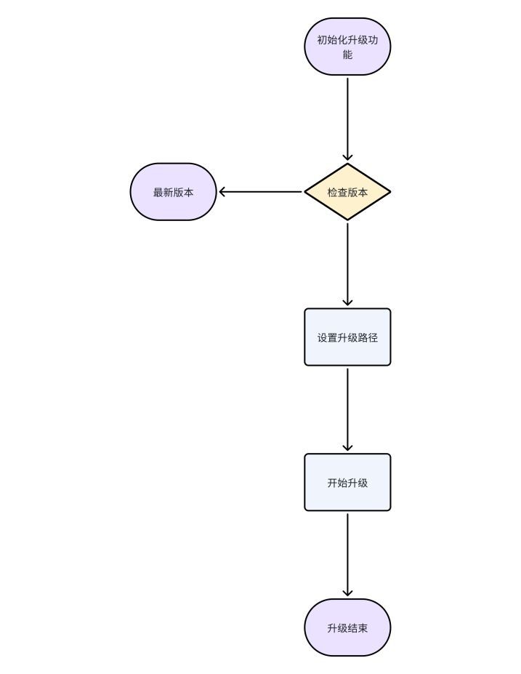

#### Check version

Interface function: Check whether the firmware version is up to date.

Interface declaration:

|  |
| --- |
| 1. OtaApi.checkVersion(String version, VersionCallback versionCallback); |

Note: To invoke this interface, ensure that it is connected to the ring

Parameter Description: version: version number of the current ring

versionCallback: indicates the latest version information callback

Return value:

|  |
| --- |
| 1. OtaApi.checkVersion(version, new VersionCallback() { 2. @Override 3. public void success(String newVersion) { 4. //newVersion: indicates the latest version number of the cloud 5. if (!StringUtils.isEmpty(newVersion)){ 6. // New version available 7. }else{ 8. // This is the latest version 9. } 10. } 11. @Override 12. public void error() { 13. // Failed to get latest version 14. } 15. }); |

#### Start leveling up

Interface Function: Perform a firmware upgrade.

Interface declaration:

|  |
| --- |
| 1. void startUpdate(BluetoothDevice bluetoothDevice, int rssi, LmOTACallback otaCallback) |

Note: To call this interface, ensure that it is connected to the ring

Parameter Description: bluetoothDevice: The device to be upgraded at present

rssi: device signal value

otaCallback: upgrade callback

Return value:

|  |
| --- |
| 1. OtaApi.startUpdate(App.getInstance().getDeviceBean().getDevice(), App.getInstance().getDeviceBean().getRssi(), new LmOTA Callback() { 2. @Override 3. public void onDeviceStateChange(int i) { 4. // Device status callback 5. } 6. @Override 7. public void onProgress(int i, int i1) { 8. // Upgrade progress 9. } 10. @Override 11. public void onComplete() { 12. // Upgrade complete 13. } 14. }); |

### Database related (DataApi)

#### Query history

Function This interface is used to query historical data for a specified time

Interface declaration:

|  |
| --- |
| 1. *// Query historical data* 2. List<HistoryDataBean> queryHistoryData(long dayBeginTime,long dayEndTime,String mac) 3. *// Query historical data in positive chronological order* 4. List<HistoryDataBean> queryHistoryDataOrderByTimeAsc(long dayBeginTime,long dayEndTime,String mac) 5. *// Query historical data in reverse chronological order of steps* 6. List<HistoryDataBean> queryHistoryDataOrderByStepCountDesc(long dayBeginTime,long dayEndTime,String mac) |

Note: The corresponding permissions need to be enabled

Parameter Description: dayBeginTime: Start time stamp, unit: second

dayEndTime: end time stamp, in seconds

mac: indicates the MAC address of the device

Return value:

|  |
| --- |
| 1. public class HistoryDataBean{ 2. @Id 3. private Long id; 4. private String mac; 5. // Total packet number 4 bytes 6. private long totalNumber; 7. // Current number of packets 4 bytes 8. private long indexNumber; 9. // Current record time 4 bytes 10. private long time; 11. // Total 2 bytes of steps today 12. private int stepCount; 13. // Heart rate 1 byte 14. private int heartRate; 15. // Blood oxygen 1 byte 16. private int bloodOxygen; 17. // heart rate variability 1 byte 18. private int heartRateVariability; 19. // Mental Stress Index 1 byte 20. private int stressIndex; 21. // Temperature 2 bytes 22. private int temperature; 23. // Motion intensity 1 byte 24. private int exerciseIntensity; 25. / * * 26. * Chronotype 1 byte 27. * 0: invalid 28. * 1: Awake 29. * 2: Light sleep 30. * 3: Deep sleep 31. * 4. Eye movement period 32. * / 33. private int sleepType; 34. // Reserve 2 bytes 35. private int reserve; 36. // The RR interval is 1 byte 37. private int rrCount; 38. //RR array data 1 byte 39. private byte[] rrBytes; 40. } |

#### Clear historical data

This interface is used to clear all historical data.

Interface declaration:

|  |
| --- |
| 1. void deleteHistoryData(); |

Note: Permissions need to be enabled

Parameter Description: None

Returned value: None

### Logical algorithm correlation (LogicalApi)

#### Calculate distance, calories

Interface function: Calculate distance and calories according to steps.

Interface declaration:

|  |
| --- |
| 1. DistanceCaloriesBean calculateDistance(int stepCount,double height,double weight); |

Note: need to enable the corresponding permissions

Parameter Description: stepCount: indicates the number of steps

height: The unit of height (cm)

weight: A unit of body weight in kg

Return value:

|  |
| --- |
| 1. public class DistanceCaloriesBean { 2. // Distance, in meters 3. private double distance; 4. // calories, unit calories 5. private double kcal; 6. } |

#### Calculate sleep data

Interface function: Calculate the specified time sleep data.

Interface declaration:

|  |
| --- |
| 1. SleepBean calculateSleep(String date, String mac, int type); |

Note: need to enable the corresponding permissions

Parameter Description: date: Date in the format YYYY-MM-DD HH:mm:ss

mac: Bluetooth MAC for the device

type: 0 indicates daily data, 1 indicates weekly data, and 2 indicates monthly data

Return value:

|  |
| --- |
| 1. public class SleepBean { 2. // Sleep sporadic hours 3. int hours = 0; 4. // sporadic minutes of sleep 5. int minutes = 0; 6. // Total sleep hours 7. int allHours = 0; 8. // Total sleep minutes 9. int allMinutes =0; 10. // deep sleep time 11. long highTime = 0; 12. // light sleep time = 0 13. long lowTime = 0; 14. // eye movement time = 0 15. long ydTime = 0; 16. // awake time = 0 17. long qxTime = 0; 18. // sleep time stamp 19. long startTime = 0; 20. // Wake time stamp 21. long endTime = 0; 22. // sleep data 23. private List<HistoryDataBean> historyDataBeanList; 24. } |

Data in database

|  |
| --- |
| 1. public class HistoryDataBean{ 2. @Id 3. private Long id; 4. private String mac; 5. // Total packet number 4 bytes 6. private long totalNumber; 7. // Current number of packets 4 bytes 8. private long indexNumber; 9. // Current record time 4 bytes 10. private long time; 11. // Total 2 bytes of steps today 12. private int stepCount; 13. // Heart rate 1 byte 14. private int heartRate; 15. // Blood oxygen 1 byte 16. private int bloodOxygen; 17. // heart rate variability 1 byte 18. private int heartRateVariability; 19. // Mental Stress Index 1 byte 20. private int stressIndex; 21. // Temperature 2 bytes 22. private int temperature; 23. // Motion intensity 1 byte 24. private int exerciseIntensity; 25. / * * 26. * Chronotype 1 byte 27. * 0: invalid 28. * 1: Awake 29. * 2: Light sleep 30. * 3: Deep sleep 31. * 4. Eye movement period 32. * / 33. private int sleepType; 34. // Reserve 2 bytes 35. private int reserve; 36. // The RR interval is 1 byte 37. private int rrCount; 38. // RR array data 1 byte 39. private byte[] rrBytes; 40. } |

# Other

Note: Check the ring status before using the ring API

## Filter Related

Blood Oxygen Ring devices broadcast under the name XXXXXX.XXX is any character and is broadcast at 500ms intervals.In this example, XXX is BCL603.

The length of the broadcast packet must be 31 bytes. If it is less than 31 bytes, the rest is filled with zeros. This part of the data is invalid

### Broadcast data unit

A broadcast packet contains several broadcast data units, also known as AD structures.

**Broadcast Data unit = Length value Length + AD type + AD Data**

The Length value length takes only one byte and is located in the first byte of the broadcast data unit.

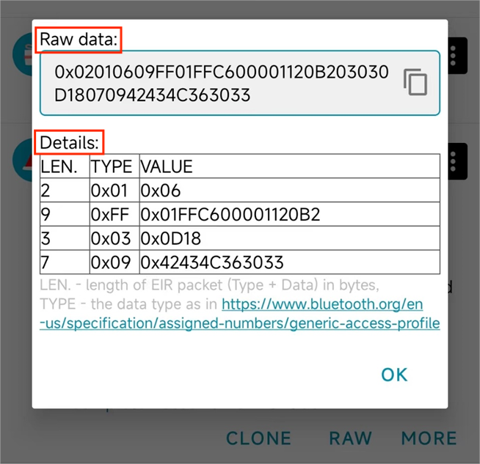

#### Raw data:

0x means the string is a hexadecimal string.Two hexadecimal numbers represent one byte.Because the maximum size of a two-character hexadecimal string is FF, that is 255, and the value range of byte type in Java is -128 to 127, which can just represent a size of 255.So two hexadecimal strings represent one byte.

Continue looking at the contents of the message and begin reading the first broadcast data unit.Read the first byte :0x02, converted to decimal is 2, that is, the following 2 bytes are the data content of this broadcast data unit.When the data content exceeds these 2 bytes, it indicates a new broadcast data unit.

For the second broadcast data unit, the value of the first byte is 0x09, which is 9 when converted to decimal, indicating that the next 9 bytes are the second broadcast data unit.

And the third broadcast data unit, the value of the first byte is 0x03, converted to decimal is 3, indicating that the next 3 bytes are the third broadcast data unit.

And so on.

In the data section of the broadcast data unit, the first byte represents the data type (AD type), determining what data the data section represents.(i.e. the second byte of the broadcast data unit is the AD type)

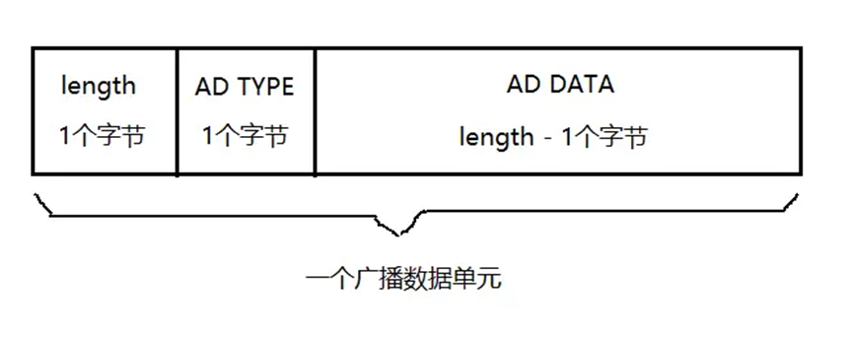

#### Details:

(1) Type = 0x01 indicates that the device LE is physically connected.

(2), Type = 0xFF indicates manufacturer data.The first two bytes indicate the manufacturer ID, that is, the manufacturer ID is 0xFF01.The last byte is the manufacturer's data, which is defined by the user

(3) Type = 0x03 indicates a full 16bit UUID.Its value is 0x0D18.

(4), Type = 0x09 indicates the full name of the device, for example, 0x42434C363033 to byte[] and then the string is "BCL603"

### Application

Note: The data transfer mode is small-end mode

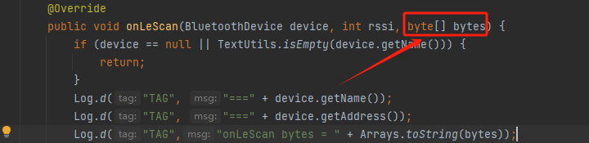

When invoking Bluetooth scan, the returned byte[] is found, here specifically [2, 1, 6, 9, -1, 1, -1, -58, 0, 0, 17, 32, -78, 3, 3, 13, 24, 7, 9, 66, 67, 76, 54, 48, 51, 0, 0, 0, 0, 0, 0, 0, 0, 0, 0, 0, 0, 0, 0, 0, 0, 0, 0, 0, 0, 0, 0, 0, 0, 0, 0, 0, 0, 0, 0, 0, 0, 0, 0, 0, 0, 0]

Note: byte data needs to be converted to hexadecimal

If you know the format and meaning of the data, set the filtering condition as the manufacturer ID == "FF01" according to the rules

Or verify "01FF" directly to the received data

## Problems that may be encountered

Materials with a simple demo, you can first view the simple demo using SDK logic, and then their own development

### Version related

Gradle version.It can be modified in gradle-wrapper.properties

|  |
| --- |
| 1. distributionBase=GRADLE_USER_HOME 2. distributionPath=wrapper/dists 3. distributionUrl=https\://services.gradle.org/distributions/gradle-8.0-all.zip 4. zipStoreBase=GRADLE_USER_HOME 5. zipStorePath=wrapper/dists |

You can download the required version at the following website, put zip in the path of wrapper/dists (in the random code folder, clean up the original), and sync it again

[Gradle Distributions](https://services.gradle.org/distributions/)

### Gradle 4.0 or higher causes Xpopup to be unusable

Xpopup is a third party popup frame, replacing it with a regular popup can solve the problem

### No interface required

ringSDK1.0.2 supports scanning, connection and other functions in service without interface

### OTA class reference not found

The following may occur:

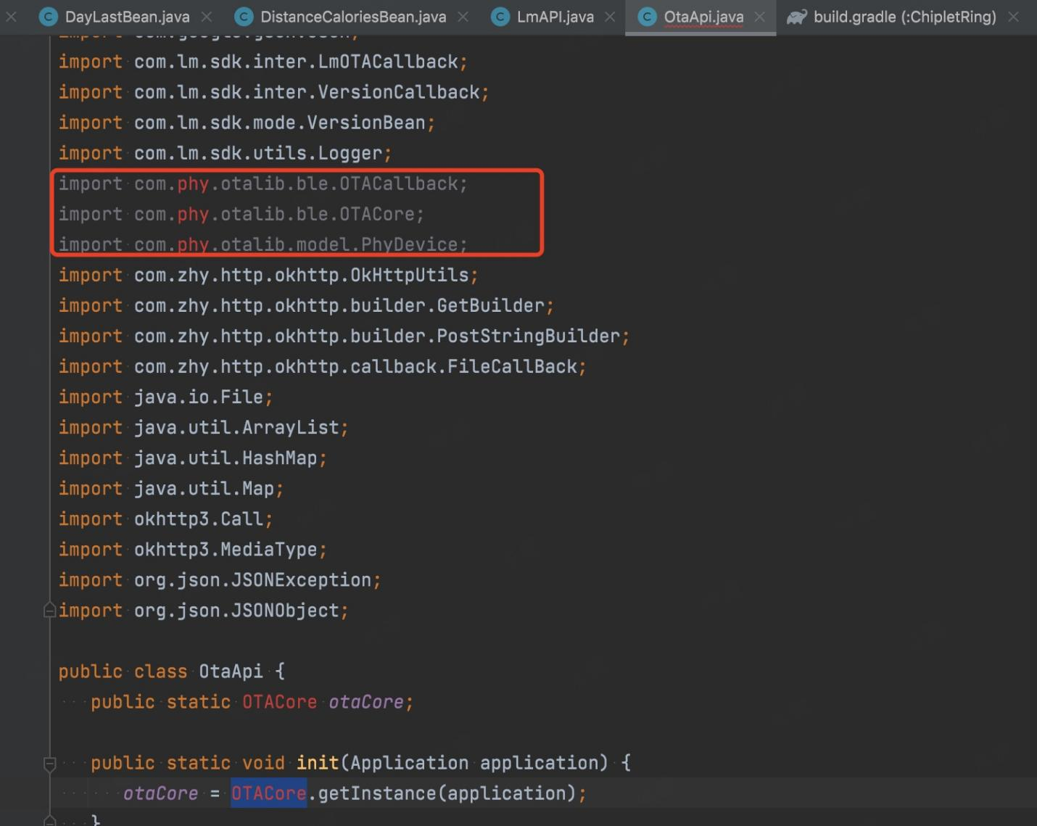

Official other dependent libraries, if you can not find, you can contact the developers of Yong core, to the original class

The original jar package has been placed under the OTA class folder of the SDK

## Hardware algorithm logic or firmware related

### Ring related

Q: How often do rings store data

A: Five minutes

Q: Does the OTA upgrade erase the data

A: Yes

Q: The data in the ring can be stored for a few days

A: Seven days, after which it is automatically overwritten

Q: Is restoring factory Settings only restoring rings

A: Yes, only for the ring hardware

### Algorithmic correlation

Q: Why does the heart rate/oxygen measurement with the SDK always display a timeout

A: The heart rate oximetry cannot be performed while the ring is charging

## Q&A

Q: When I read history records, do I report that each tag has been synchronized, or do I upload the whole tag?

A: One mark at a time

Q: What are the limitations of the collection cycle setting

A: The unit of the collection period is second. The normal value is at least 60s. 0 indicates that the collection is closed.